CNH Industrial Supplier Portal

Logon for first time as supplier

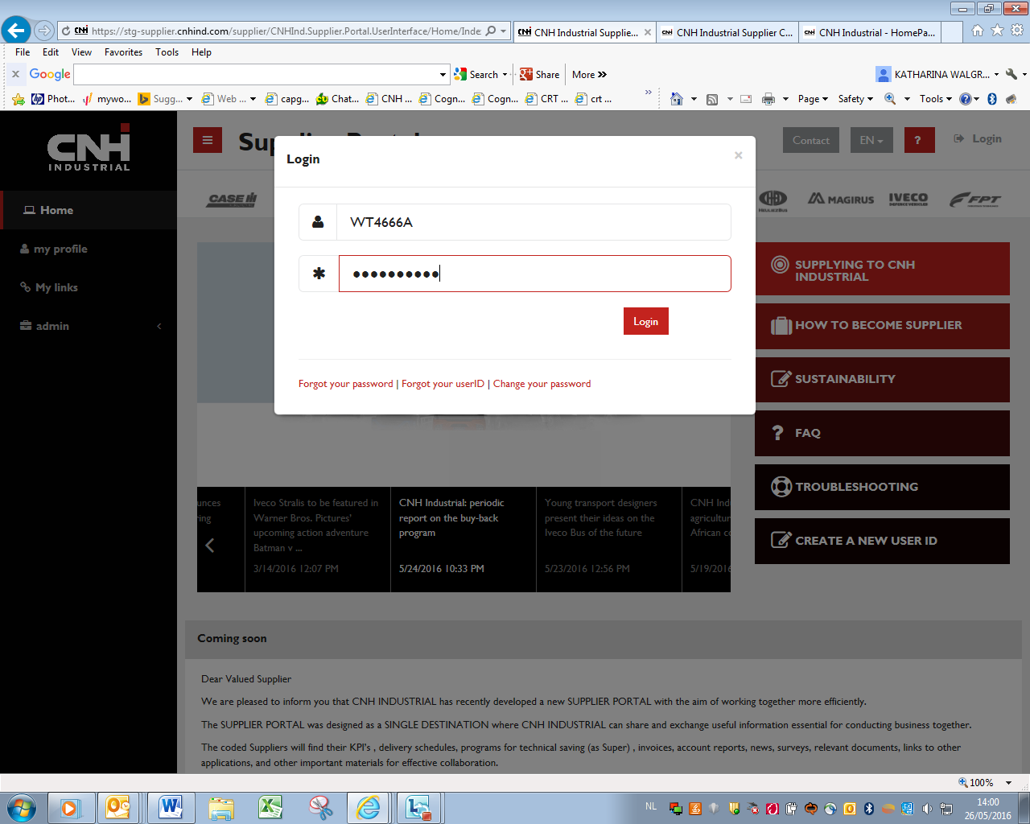

Check your credentials
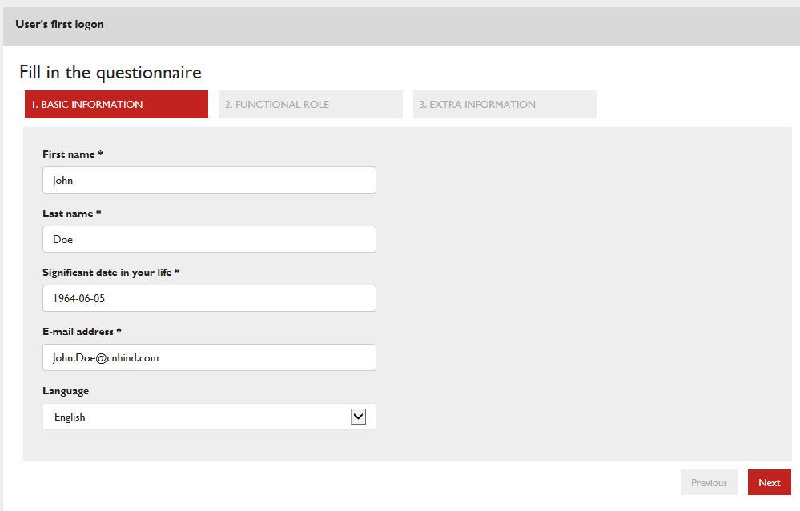

Select if you want to be the administrator for your company (only for this group) for this portal.
Select based on your role in your company an extra functional group.

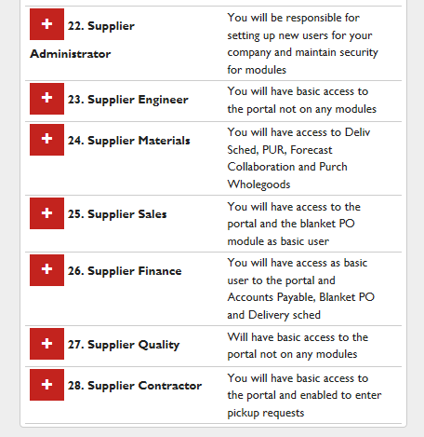

Then fill in the rest of the questionnaire :

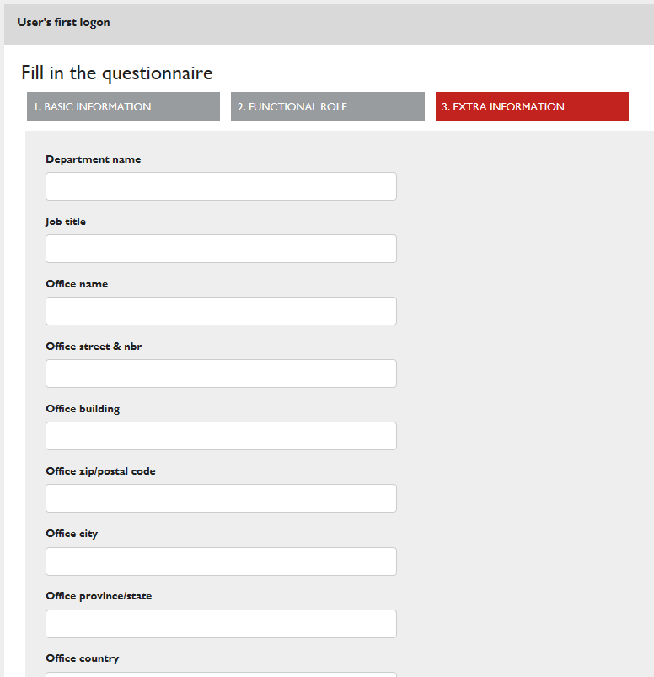

Click on FINISH
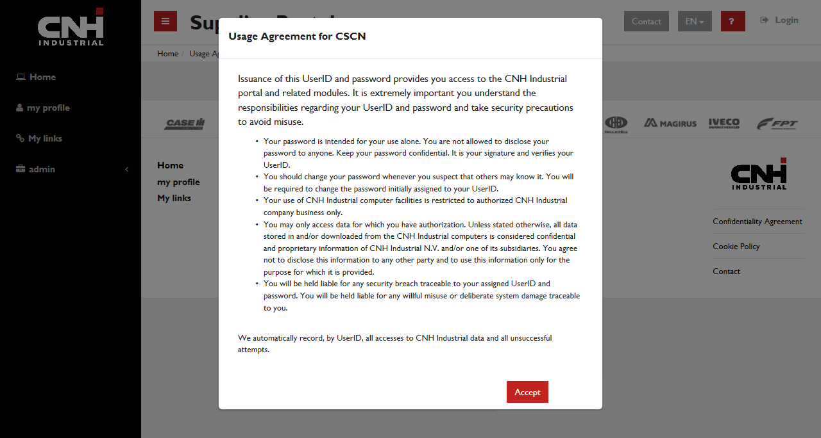

Read carefully and click Accept to continue, the acceptance is registered and the portal will ask renewal of the acceptance yearly

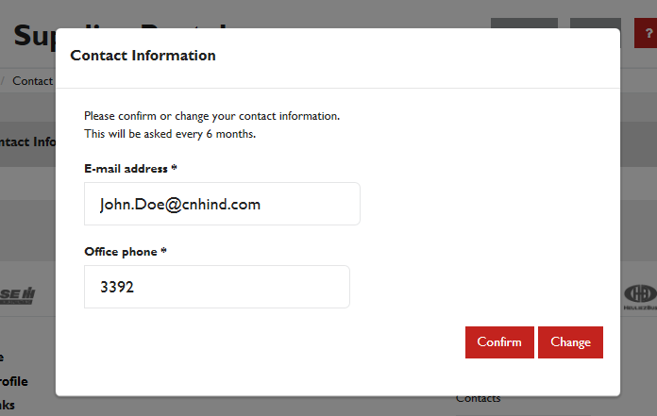

Email addresses will have to be confirmed every 6 months as a lot of features use email notification.

Mandatory Contacts

CNH Industrial needs to be in contact with its suppliers on a regular basis to exchange information related to different areas of our collaboration. In order to address our communications properly, we kindly ask you to fill and keep updated contact information field for each of the indicated areas.

As soon as your userID is being mapped a POPUP screen will appear to request you to fill in contact information on the portal. This information is used in many of our backend systems.

<printscreen>

