CNH Industrial Supplier Portal

Create New User ID

Internal company users have access to the portal with their normal network userID and passwords.
External users to the company need to register.

Fill in with whom you have contact internal at the company, this person will be contacted to approve your access registration.

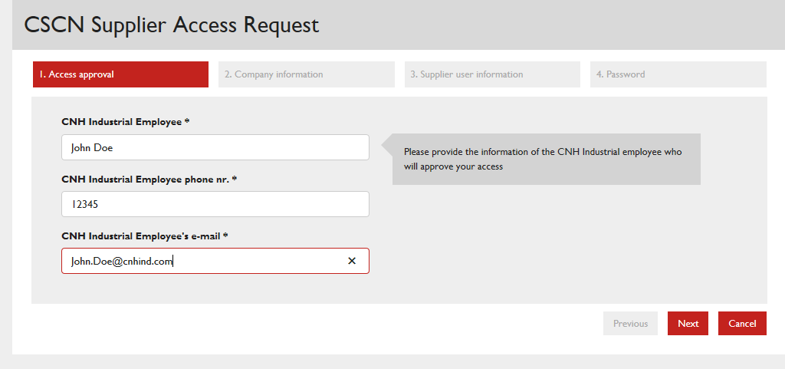

Click Next button
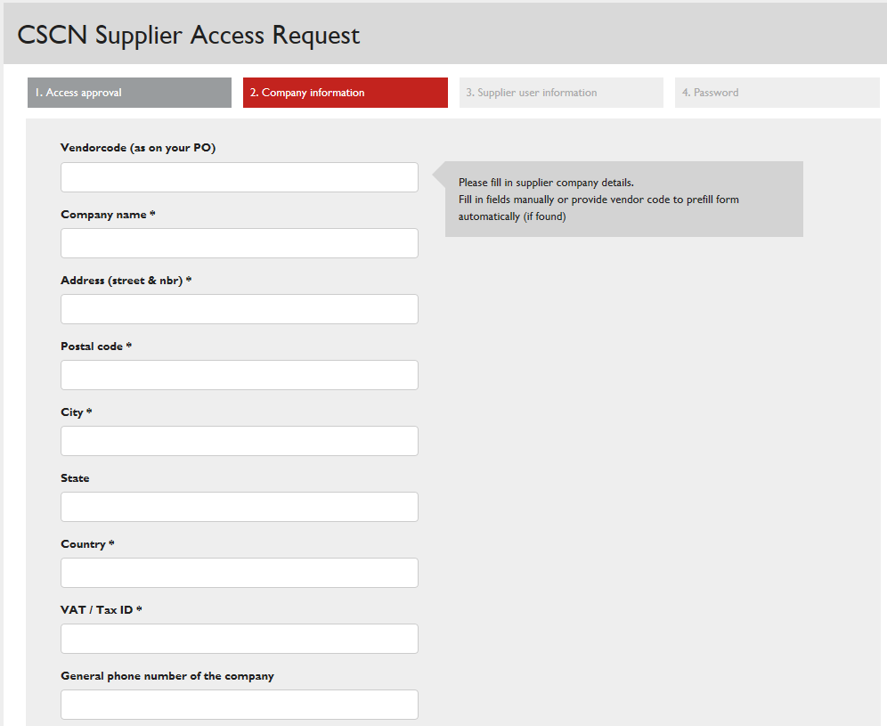

If you are an active vendor, fill in your vendorcode this will prefill all other fields as well; it is important to be able to link your userID to your company group. Select the vendorcode of your location or nearest by location of your office.
If you are not an active vendor yet, please fill in your company information.
Click Next button
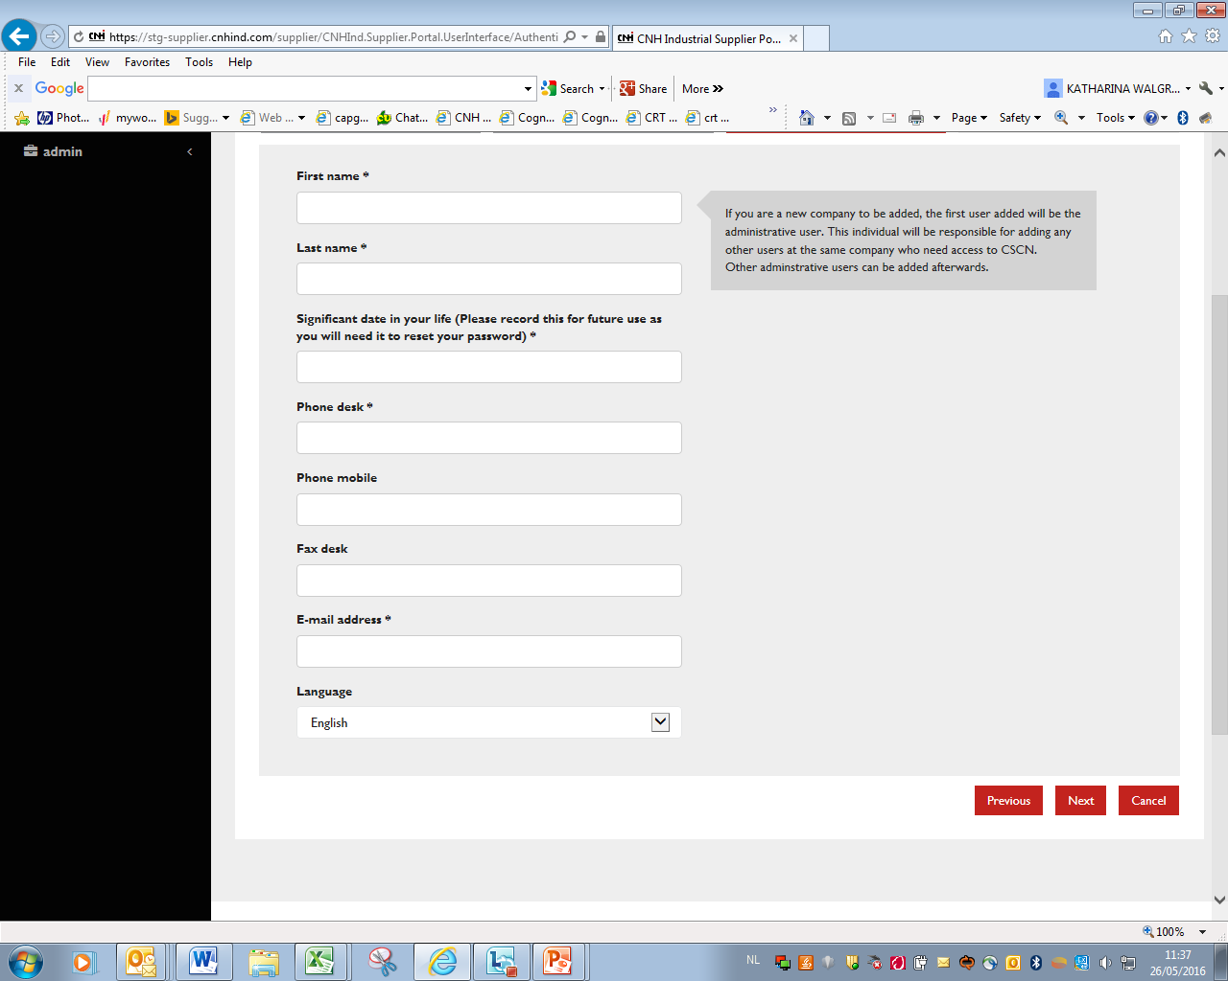
Enter your own personal data
Click Next button
The system requests to enter your chosen password twice, then after sumbitting your registration is completed.

Your registration is kept in a repository for administrators to check and accept or reject. You will get email notification accordingly based on your entered email address during registration.


